**VISUAL STUDIO SETUP**

1. 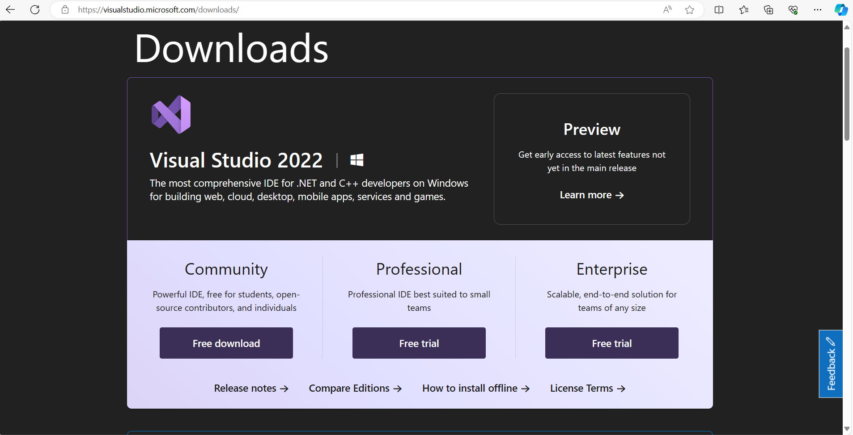**Go to Visual Studio download from the Microsoft Official Website.**
2. **From here click on Community Free download button.**
3. 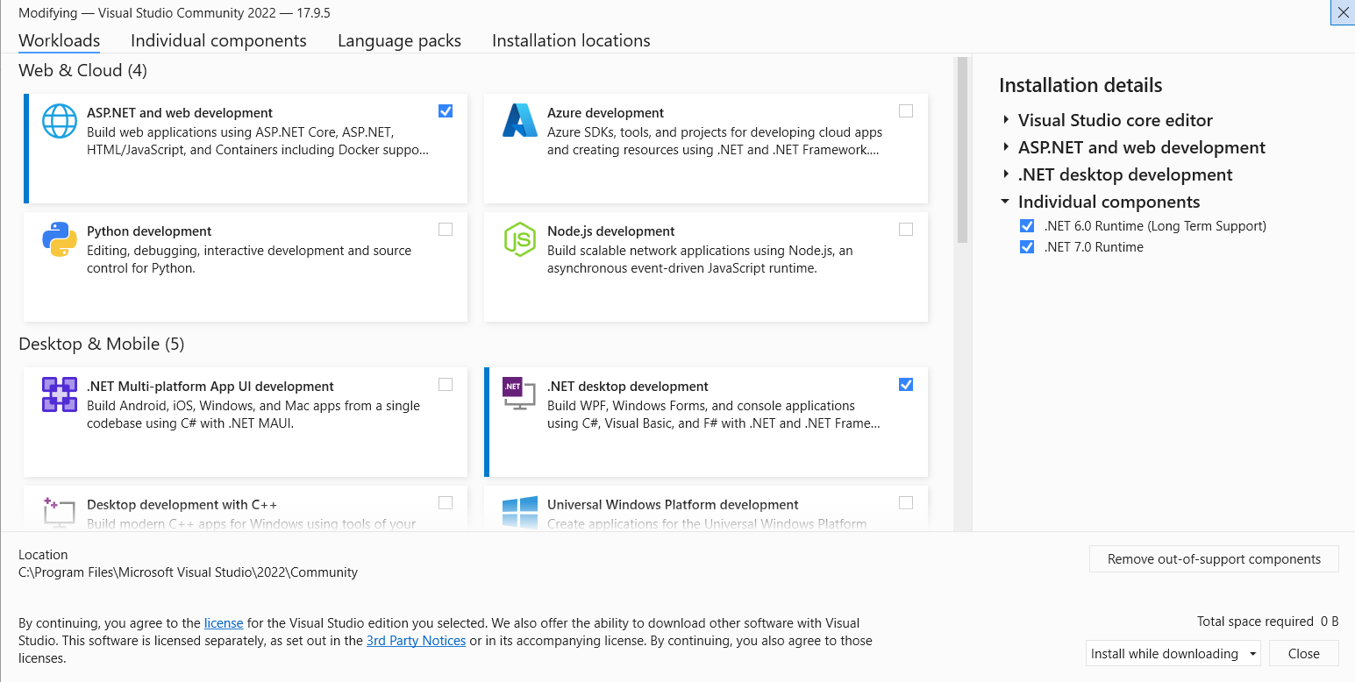**After downloading open the downloaded file.**
4. **Now you can select the required work loads from the list.**
5. 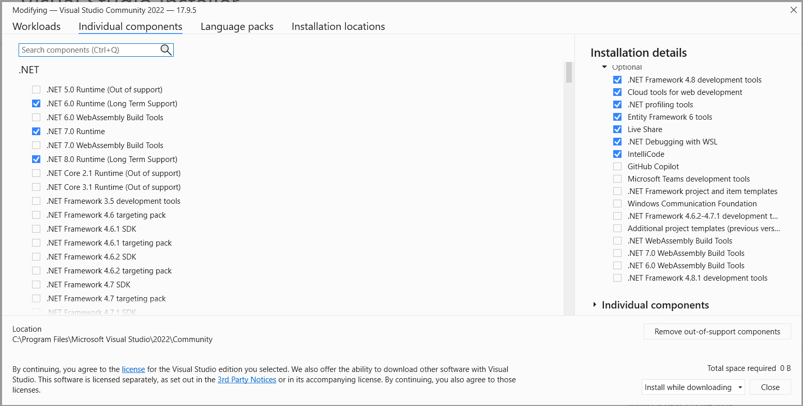**You can also select the individual components of .Net from the Individual components tab.**
6. **Then click Install button.**
7. **Now the download will start, and depending upon your internet and workloads you have selected it may take some time to download.**
8. **After Downloading open Visual Studio 2022 application.**

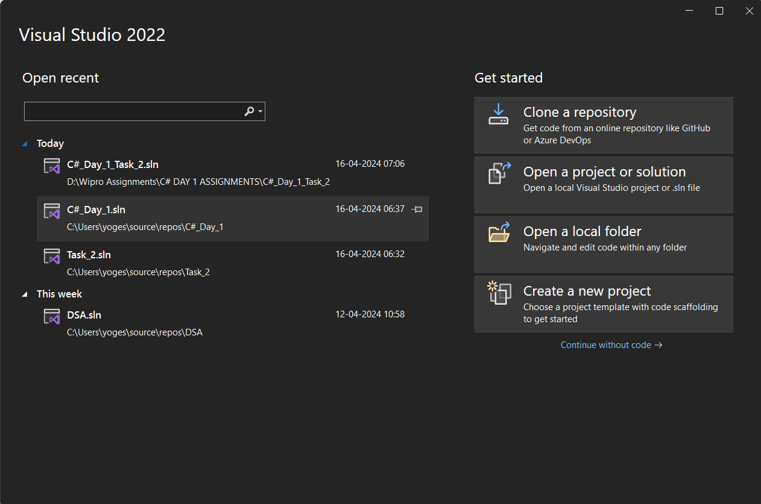

1. 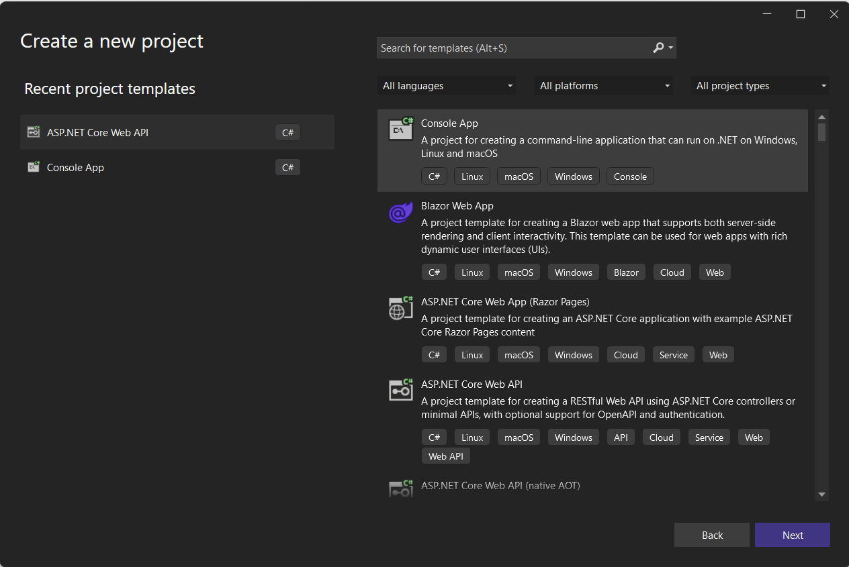**Select Create a new Project.**
2. 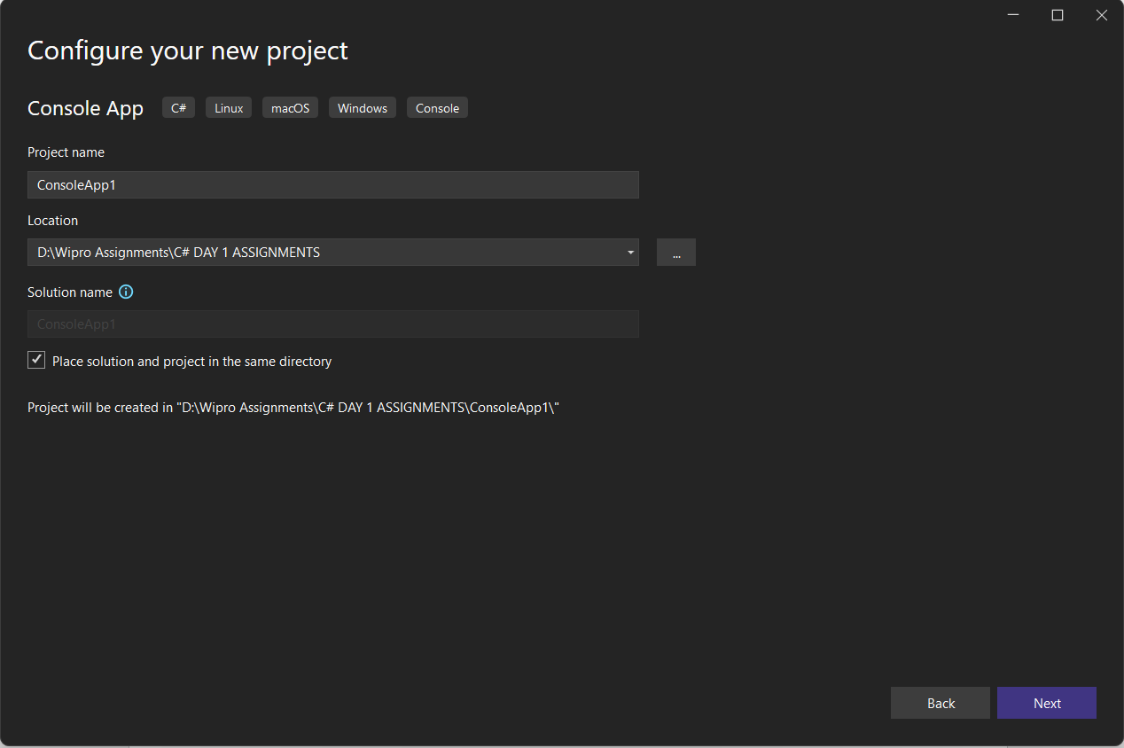**Select the template and click next.**
3. **Enter your Project name and click next.**
4. 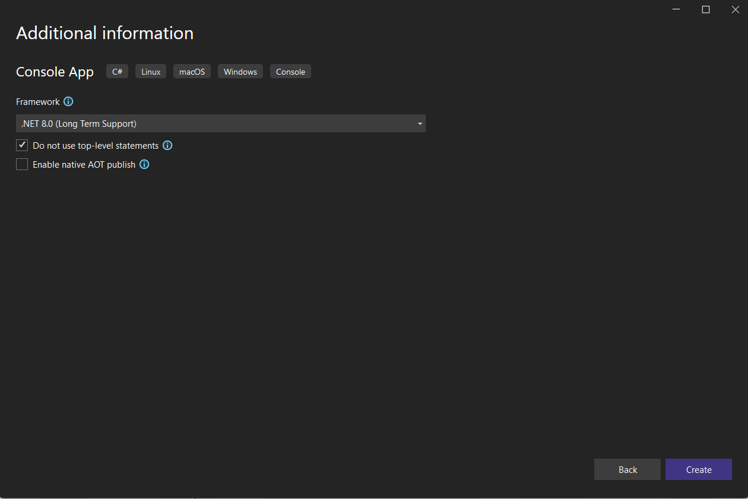**From the Framework down you can select the .Net version. It will show versions that you have downloaded in step 5.**
5. 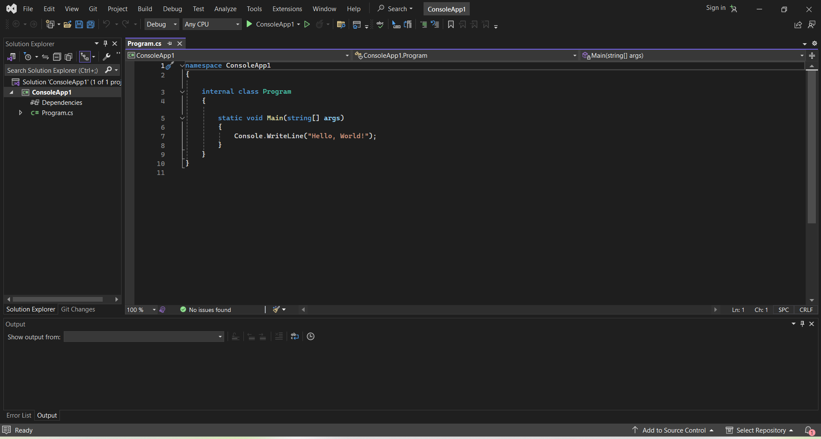**Then click Create.**
6. **The starter template is ready top use.**